SUPERIOR DEL MAIPO HIGH SCHOOL

**Handout 6 Elective**

DEPARTMENT OF ENGLISH

Teachers Arturo Jirón Tapia

Celeste Santibáñez Ponce

Name: ___________________________ Grade: **4th** ____ Date: _________________

*Week from 10 to 14 of August*

I.- Translate into Spanish the conversation between the mother and her children.

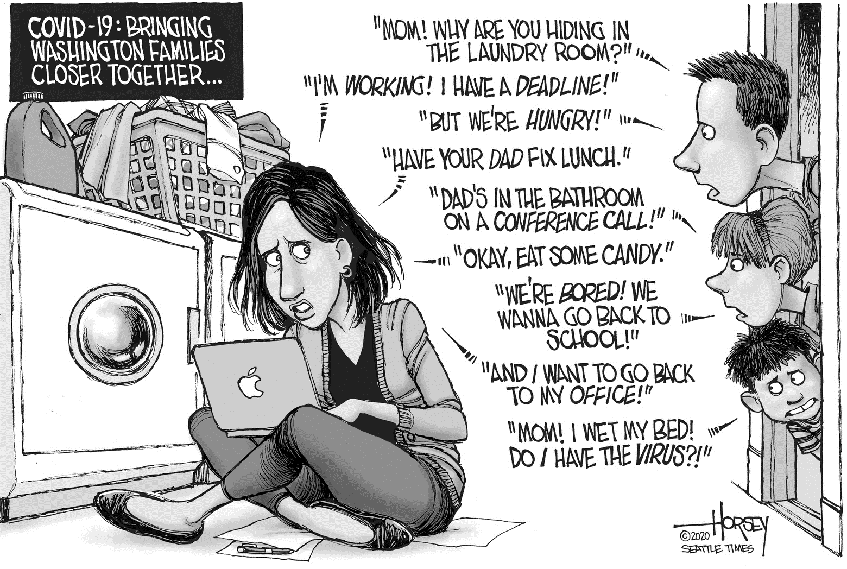

|  |
| --- |
| TITLE  _________________________________________  _________________________________________ |

Big boy: _____________________________________________________________________________________

Mom: _______________________________________________________________________________________

Big boy: ______________________________________________________________________________________

Mom: ________________________________________________________________________________________

Girl: __________________________________________________________________________________________

Mom: ________________________________________________________________________________________

Girl: __________________________________________________________________________________________

Mom: ________________________________________________________________________________________

Little boy: _____________________________________________________________________________________

II.- Choose the best word(s) to complete each sentence.

1. The ______ hurricane winds tore down houses and uprooted trees.

A. furious B. tame C. mild D. moderate E. humid

2. It takes ______ hands to hit a target with a bow-and-arrow.

A. delicate B. rough C. agile D. steady E. manicured

3. Unlike the ______ skin of a frog, that of a toad is more textured and ______.

A. slick ... slimy B. tough ... scaly C. greasy ... oily

D. green ... black E. smooth ... bumpy

4. Despite her friends’ best efforts at making her feel ______, Molly felt very ______ at the party.

A. sociable ... old B. relaxed ... uncomfortable C. humorous ... silly

D. helpful ... generous E. miserable ... sad

5. The copied version was ______ reproduction; it was remarkable how closely it resembled the original.

A. an ancient B. a false C. an accurate D. an authentic E. a genuine

6. All of the initial reviews were rather ______, whereas the more recent ones seem overwhelmingly ______.

A. scathing ... positive B. great ... upbeat C. helpful ... insightful

D. negative ... doubtful E. fake ... phony

7. Despite usually being ______, Lina was ______ when confronted by the dangerous bear.

A. tired ... drowsy B. lost ... disoriented C. arrogant ... courageous

D. cowardly ... brave E. afraid ... frightened

8. The ______ shopkeeper ______ us; we certainly won’t buy anything from him again.

A. generous ... welcomed B. polite ... thanked C. greedy ... overcharged

D. kind ... hated E. sleepy ... excited

III.- Choose the answer choice that best defines the word in capital letters.

1) CRUCIAL

A. very important B. very ugly C. very difficult D. very loud

2) MIMIC

A. to confuse B. to affect C. to remove D. to copy

3) DISTINCT

A. silent B. smooth C. sticky D. separate

4) MAJORITY

A. a loud noise B. a larger part C. a beginner D. a long story

5) RETRIEVE

A. to bring back B. to shrink C. to include D. to look for

6) ANXIOUS

A. nervous B. colorful C. relaxed D. entertaining

7) ORIGINATE

A. to exercise or train B. to rest or relax C. to start or begin D. to get old or age

8) FUNCTION

A. to remove B. to answer C. to purchase D. to work

9) CONQUER

A. to be defeated B. to hope for C. to write D. to take over

10) REFUSE

A. to remove or withdraw B. to doubt or question

C. to make better or to improve D. to deny or not accept

IV.- Read the dialogue, then answer the identify the answer for the 8 questions.

“Glasses”

Nancy: I love your glasses!

Juana: Thanks. They’re brand new.

Nancy: You look great. They’re very flattering.

Juana: Thank you.

Nancy: Can I try them on?

Juana: Sure. Go ahead, try them on.

Nancy: Thanks. Now I need a mirror.

Juana: Okay, I have a little one in my purse.

Nancy: Oh! I feel dizzy! It must be the glasses!

Juana: Take a look at yourself.

Nancy: I look terrible!

Juana: Don’t be silly. You look cute in them.

Nancy: I look all blurry!

Juana: That’s because the glasses are my prescription, not yours.

Nancy: Oh, so that explains why you didn’t look blurry to me when you had them on.

Juana: You’re not serious, are you?

Nancy: Why do you say that?

Juana: You weren’t wearing my glasses when you looked at me!

Nancy: Oh! That’s’ right! You were wearing them!

Juana: Umm, yeah.

Nancy: And you looked great in them!

Juana: Hehe, thank you.

Questions:

1) What does Nancy want to do?

A. Take home Juana’s glasses B. Look at Juana’s glasses

C. Try on Juana’s glasses D. Buy Juana’s glasses

2) How does Nancy feel when she puts on Juana’s glasses?

A. Confused B. Blurry C. Dizzy D. Silly

3) What does Juana carry in her purse?

A. A pair of glasses B. A prescription C. A mirror D. A phone

4) How does Nancy appear to herself in the mirror?

A. Serious B. Blurry C. Great D. Cute

Vocabulary:

1) Nancy tells Juana the glasses are flattering. She means that the glasses…

A. are shiny like a mirror. B. make Juana look good.

C. are a good brand. D. look new.

2) Blurry means…

A. composed of multiple colors. B. out of focus. C. frightening. D. wonderful.

3) In this dialogue, a prescription is…

A. a doctor’s order for corrective lenses. B. the color of the pair of glasses.

C. a small mirror. D. eye strain.

4) Juana says to Nancy, “You’re not serious, are you?” She wants to know if Nancy is…

A. wearing her glasses. B. joking with her.

C. bothering her. D. lying to her

V.- Fill in the blanks in the passage below.

“Bears”

|  |  |  |  |
| --- | --- | --- | --- |
| a.- called sows | b.- drink milk | c.- seven feet tall | d.- its hind legs |
| e.- with their mother | f.- the next summer | g.- open spaces | h.- in the den |



American Black Bears live in the U.S., Canada, and Mexico. An American Black Bear can be up to (1)______ if it stands on its hind legs. A mother Black Bear can have 2-4 baby bears. They have the bears in winter. The baby bears are called cubs. During the winter, the cubs stay (2) ______in the bear den. During the summer, the cubs like to go outside. They like to run and play. The cubs (3) ______ provided by their mother. The cubs eat nuts, berries, and insects. The cubs also love to eat honey. During the winter, the cubs sleep (4) ______ with their mothers. They rest all winter. The cubs will leave their mother (5) ______. They will move away to start their own family.

Brown Bears live in the North. They live in Wyoming, Montana, Idaho, Washington, Alaska, Canada, and northern Eurasia. Brown Bears are very big. A Brown Bear can be up to ten feet tall if it stands on (6) ______. Like Black Bear cubs, Brown Bear cubs are born in winter. They drink milk until spring or summer. The mothers have 2-4 cubs. Brown Bear cubs stay with their mothers for 2-4 years. The adult females, (7) ______, teach them to hunt. They like to hunt at night. They like to hunt in large, (8) ______. Brown Bears eat mostly fruits and vegetables, but they also hunt and eat other animals.